SOP Document For the Diamond Map Bot

1. Root Folder Configuration
The primary prerequisite is the establishment of a dedicated root folder for the bot's operations.
- Location: The designated root folder must be located at E:\RPA. This specific path is crucial for the bot to correctly locate its necessary components and process files. Any deviation from this path will result in operational failures.

1. Subfolder Structure within the Root Directory
The Diamond Map Bot requires a specific subfolder structure within the E:\RPA root folder to organize its various data and files. These subfolders categorize inputs, outputs, and supporting imagery as follows:
- 'DIA MAP': Stores the diamond map of the design file, named after its corresponding design code.
- 'MAP CAD IMG': Contains CAD images with the map image incorporated, named with the corresponding design code.
- 'excels': Designated for all Excel-based files used by the bot, including input and completed files.
- 'EXE': A critical subfolder containing all executable files and supporting data files necessary for the bot's functionalities.

2. Essential Data Files within the 'excels' Folder
The excels folder, located at E:\RPA\excels, must contain several specific Excel files to facilitate the bot's workflow and record-keeping:
- input.xlsx: Serves as the primary input for records, with the design file path in the first column, image file path in the second, and design code (used for naming) in the last.
- completed.xlsx: Records are added here with a datetime stamp after successful processing, serving as a history of completed tasks for auditing and tracking.
- skip.xlsx: Records that cannot be processed (e.g., system hung, no map generated, file not found) are moved here to aid in identifying and troubleshooting issues without halting the entire process.
- to_run_records.xlsx: Holds records queued for immediate processing or currently being worked on by the bot for diamond map generation, acting as a dynamic list of active tasks.

3. Required Executable Files within the 'EXE' Folder
For the Diamond Map Bot to perform its various functions, the EXE folder must also contain a collection of specialized executable files, each responsible for a distinct operation within the bot's workflow:
- completed.exe: Likely handles the finalization of processed tasks, potentially moving data to completed.xlsx or performing post-processing.
- crop.exe: Used for cropping images, possibly to isolate diamond map sections or prepare images for analysis.
- image_impose.exe: Responsible for superimposing or overlaying images, used for combining CAD images with diamond maps.
- isWhite.exe: Probably checks if a diamond map image is completely white, indicating no map has been generated.
- killed.exe: Kills the MatrixGold application when it becomes unresponsive.
- preprocess.exe: A crucial executable that runs initially to check for new records in the input file.
- skip.exe: Manages records that need to be skipped due to a hung system, empty map creation, or file not found issues, moving them to skip.xlsx to ensure they do not impede the main processing flow.
By diligently setting up these folders and ensuring all required files are present in their specified locations, users can ensure the Diamond Map Bot operates smoothly and efficiently, fulfilling its intended mapping and processing functions. Regular verification of this file structure is recommended to maintain optimal performance.

2. RPA Launcher Usage Guidance: A Detailed Walkthrough
This section outlines the steps required to effectively utilize the RPA Launcher. Please follow these instructions carefully to ensure proper functionality and successful execution of your tasks.

1. Downloading and Extracting the Require Files
To begin, you need to obtain the necessary files. These files are provided in a compressed .zip format.
- Download Location: Access the compressed file from the following Google Drive link: Download.
- Extraction Process: Once the download is complete, locate the downloaded .zip file. You must extract its contents. It is crucial to extract the folder directly into your E: drive. This ensures the bot can locate all its necessary components and dependencies. The extracted folder is named "RPA".

2. Preparing the Input Data Excel File
After extracting the bot files, the next critical step involves preparing your input data. The RPA bot relies on a specific Excel file to understand which designs to process.
- File Location: Navigate to the extracted folder. Inside, you will find a sub-folder structure leading to the input Excel file. The precise path is E:\RPA\excels\input.xlsx.
- Opening the File: Open the input.xlsx file using Microsoft Excel or a compatible spreadsheet application.
- Column Structure and Data Entry: This Excel file is pre-formatted with three essential columns, each with a specific heading. You must populate these columns accurately for each design you wish the bot to process.
  - 'Design Path': This column requires the absolute file path to your .3dm design file. Ensure the path is correct and points directly to the design file on your system.
    - Example: C:\Designs\Jewelry\Ring_Design_A.3dm
  - 'Image Path': This column requires the absolute file path to the corresponding image file for your design. This image is typically a preview or rendered image of the design.
    - Example: C:\Images\Rendered\Ring_Design_A_Render.jpg
  - 'Design Code': This column is for the unique design code associated with each design. This code helps in identifying and categorizing the designs.
    - Example: RG-31520-100
  - Important Note: It is imperative to add all the design file paths, image file paths, and their respective design codes for every single design you intend the bot to run for. Each row in the Excel sheet should represent one complete design entry. Incomplete or incorrect entries may lead to errors or the bot skipping certain designs.
  - Screenshot of the Input Excel:.The input file structure has columns: 'Design Path' for .3dm files, 'Image path' for corresponding images, and 'Design Code' for the design code.
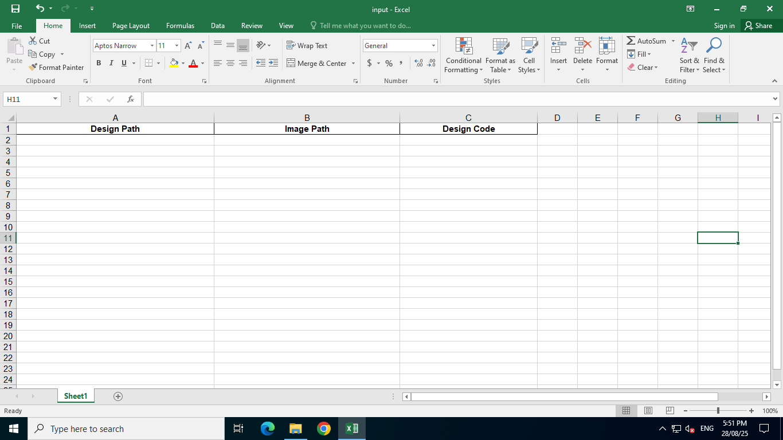
  - Add Paths and Codes: Add your .3dm file paths, corresponding image paths, and design codes. Look at the example below and save and close the file.
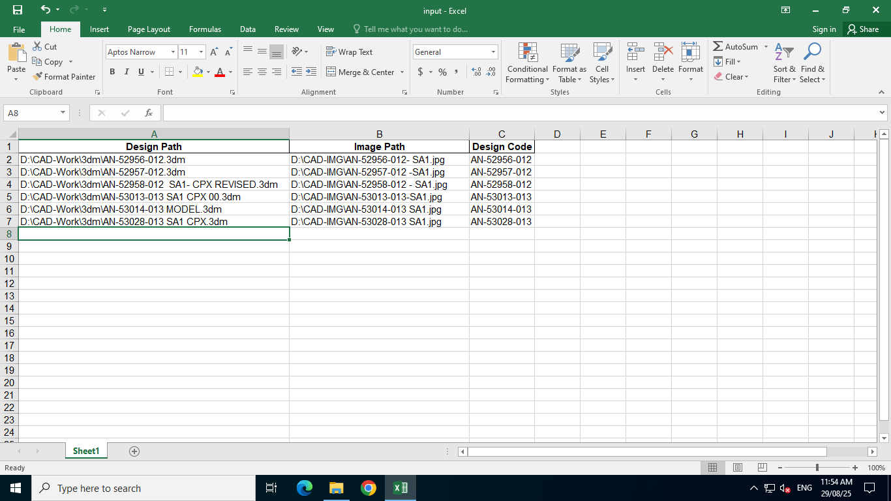

3. Launch the RPA Launcher:
- Navigate to the desktop and double-click the "IBM RPA Launcher" icon to start the application.
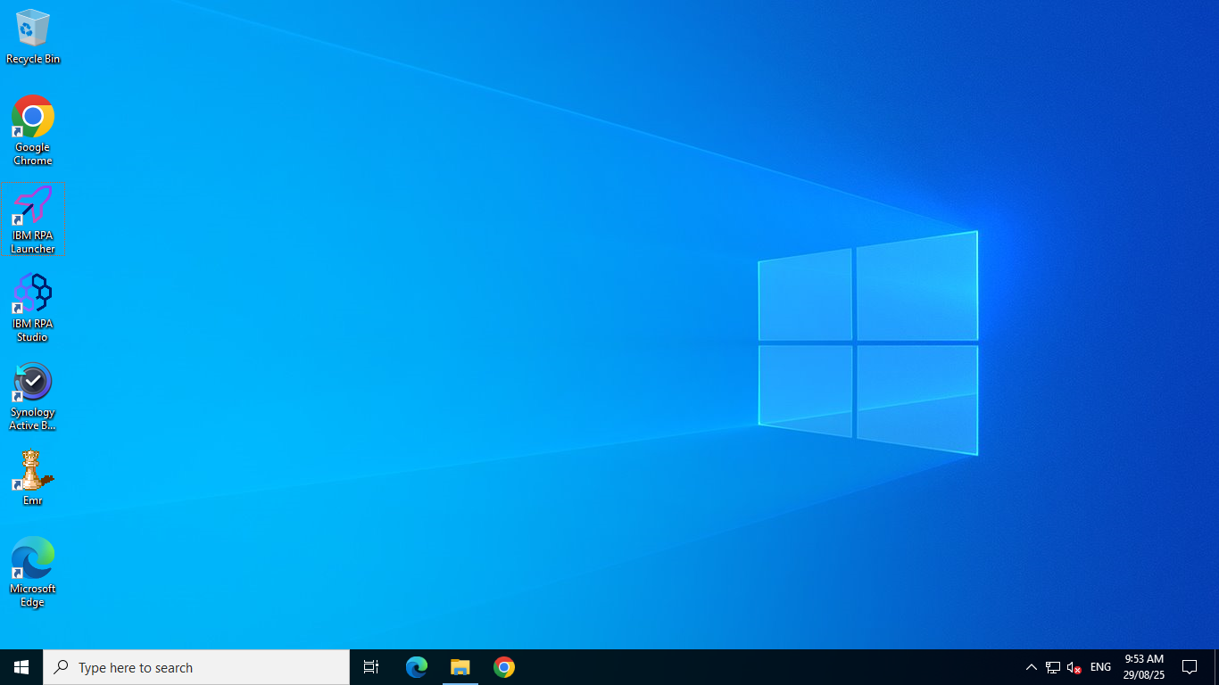
- Obtain your email ID and set your password (if not, contact the RPA administrator). Then, log in to the RPA launcher by entering your email and clicking "Continue."
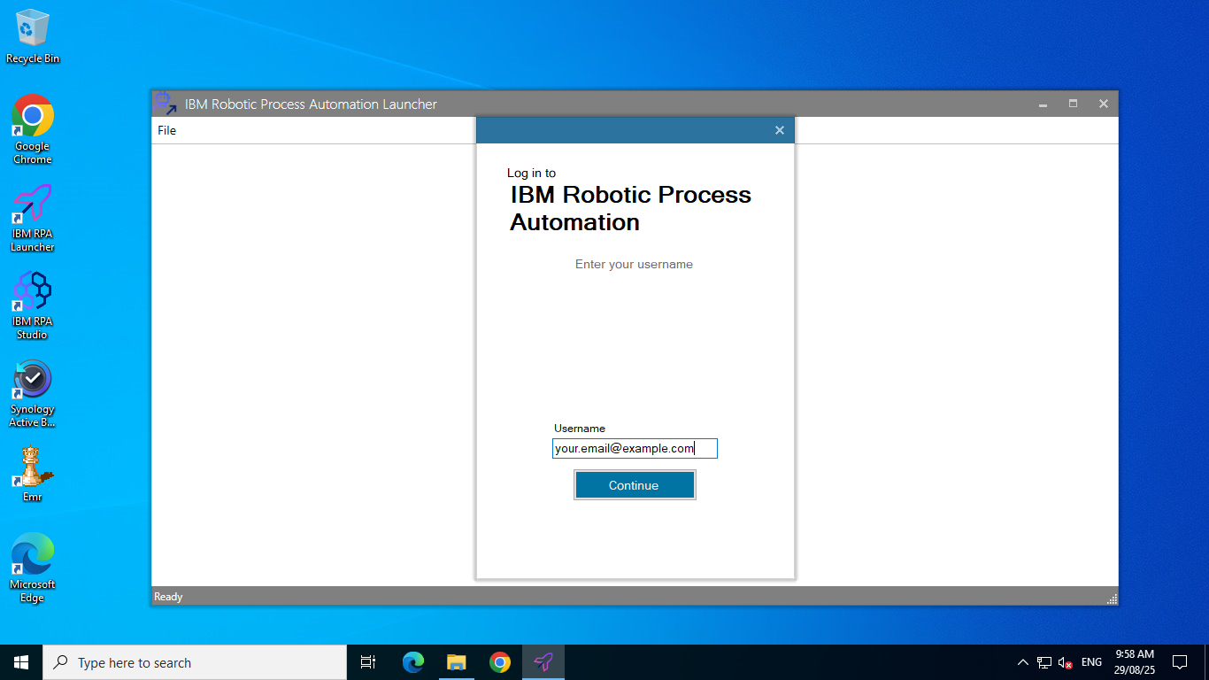

- On the next screen, input your password and click "Login" to access the launcher.
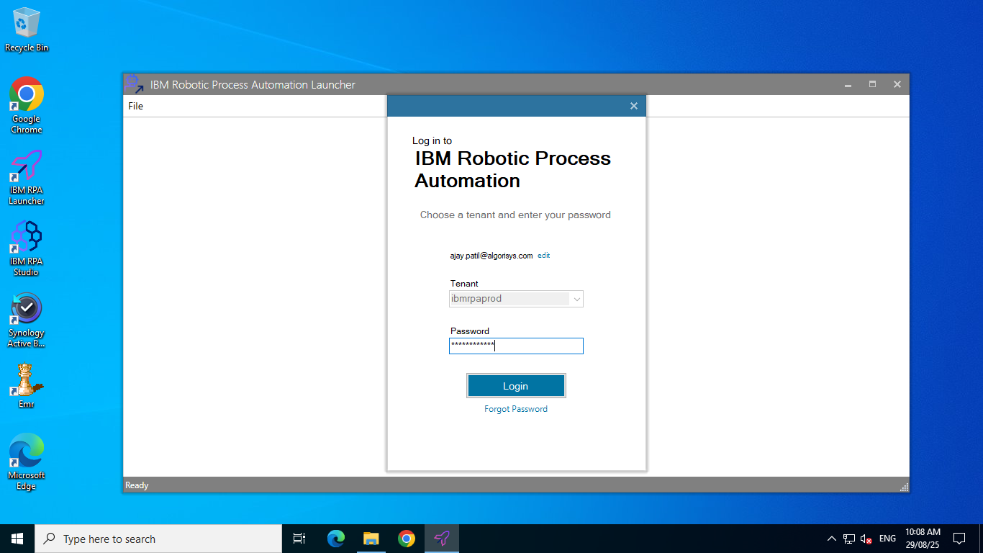

- After login on the launcher's main screen, double-click the "MatrixGold Diamond Map Bot" button to initiate the bot's execution. You will see the name "MatrixGold Diamond Map Bot" displayed at the top.
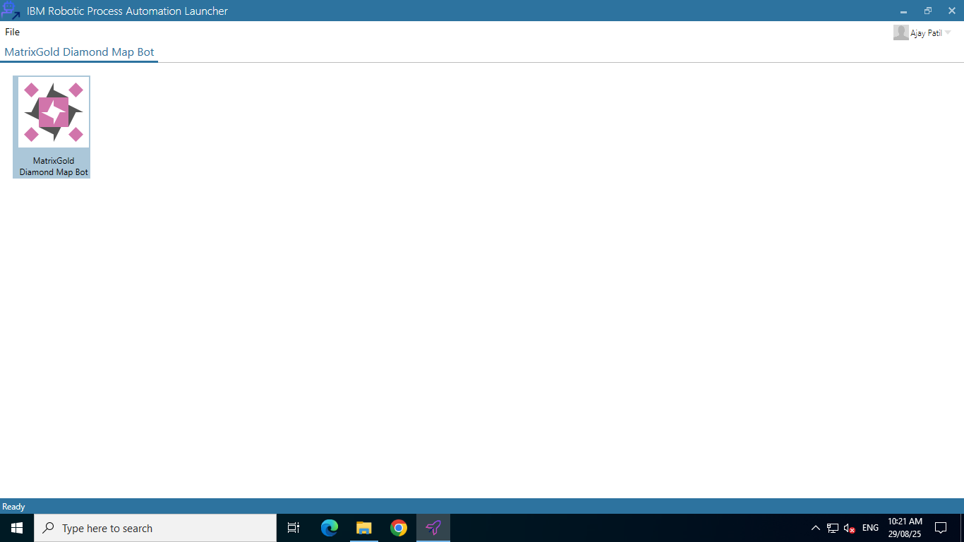

Now the execution has been started, its operational workflow begins with a critical preprocessing phase. Initially, the bot utilizes a dedicated executable, preprocessing.exe, to prepare the input file, to_run_records.xlsx. This step is crucial for organizing and validating the data that will be used to generate the diamond maps.

Once the to_run_records.xlsx file is prepared, the bot proceeds to execute each record contained within it sequentially. This systematic approach ensures that every diamond map creation request is processed individually and thoroughly. As the bot processes each record, it categorizes the outcomes into two distinct groups to maintain clear tracking and accountability.

For every record that the bot successfully executes and for which a diamond map is created without any errors, the corresponding data is appended to the completed.xlsx file with datetime stamp. This file serves as a comprehensive log of all successful operations, providing a reliable record of completed tasks.

Conversely, if a record encounters an error during execution, preventing the successful creation of a diamond map, that record is then added to the skip.xlsx file. The skip.xlsx file acts as an error log, detailing all records that could not be processed automatically. Records listed in the skip file require manual intervention to complete the diamond map creation process. This manual execution is necessary to troubleshoot the specific errors and ensure that all outstanding diamond maps are eventually generated, maintaining the integrity and completeness of the overall mapping project.

4. Bot Operation Procedure:
- Preparation (Preprocessing):
  - The bot first runs a program called Preprocessing.exe.
  - This program checks existing records and creates a file named record_to_run.xlsx. This file tells the bot which design records it needs to process.
- Starting MatrixGold Software:
  - The bot then launches the MatrixGold software, which is the primary design software.
  - The bot waits patiently until the MatrixGold software is fully open and ready to use.
- Opening Design Files:
  - Once MatrixGold is open, a "Open File" window is opened.
  - The bot uses the path information from the record_to_run.xlsx file to open the corresponding design.
  - Error Handling (File Not Found): If the design file cannot be found at the specified path, the bot logs this record in a "skip" file (e.g., skip.xlsx) with the reason "Not Found." In this case, the bot skips all further steps for this specific record and moves on to the next design.
- Importing Legacy Map:
  - After the design file successfully opens on the screen, the bot clicks a "Legacy Import" and imports the Gem Map.
- Accessing Gem Map Feature:
  - The bot then clicks on the "Tools" menu within MatrixGold.
  - From the "Tools" menu, it selects "Gem Map."
  - The bot waits for the "Gem Map" window to appear, indicating that the feature is ready to be used.
- Error Handling (System Hang):
  - Critical Check: If the system freezes or becomes unresponsive at any point during this process, the bot adds the current record to skip.xlsx with the reason "System Hung."
  - In such a scenario, all subsequent steps for that record are skipped, and the bot proceeds to the next design.
- Diamond Map Creation and Validation:
  - If the "Diamond Map" window successfully appears, the bot performs the following actions:
    - It takes a screenshot of the window.
    - It crops any unnecessary parts of the screenshot.
    - Map Validation (White Map): The bot then checks if the cropped image of the map is completely white. A completely white map indicates an issue where the map wasn't generated correctly.
    - Retry Mechanism: If the map is completely white, the bot changes the view within MatrixGold and attempts to create the map again.
    - Error Handling (Map Not Found): If, after two retries, the map is still white, the bot logs this record in skip.xlsx with the reason "Map not found." All subsequent steps for this record are skipped, and the bot moves to the next design.
- Saving the Diamond Map:
  - If the bot successfully generates a non-white diamond map after up to two retries, it saves this map.
  - The map is saved in a folder named "DIA MAP."
  - The file name of the saved map corresponds to the unique "Design Code" of the current design.
- Combining Images (Map and CAD):
  - The bot then takes the path to the original CAD (Computer-Aided Design) image and the path to the newly created diamond map image.
  - These two paths are provided to a program called image_impose.exe.
  - This program combines the CAD image and the diamond map image into a single, composite image.
  - The combined image is saved in a folder named "MAP CAD IMG."
  - The file name of this combined image also corresponds to the "Design Code."
- Recording Completed Designs:
  - Once a design's map creation process is successfully completed (including saving the combined image), the record for that design is added to completed.xlsx.
  - A timestamp is also added to this record, indicating when the process was finished.
- Closing and Moving On:
  - The bot then closes the current design file in MatrixGold.
  - It proceeds to open the next record from the record_to_run.xlsx file.
  - This entire sequence of steps (from opening the file to recording completion) is repeated for each design record one by one.
  - After all records have been processed, the MatrixGold software is closed.
  - Finally, users can review the completed.xlsx file (for successfully processed designs) and skip.xlsx file (for designs that encountered issues) in the folder E:\\RPA\\excels\\.
  - Please find out below screenshots of the completed.xlsx and skip.xlsx.

- Completed.xlsx
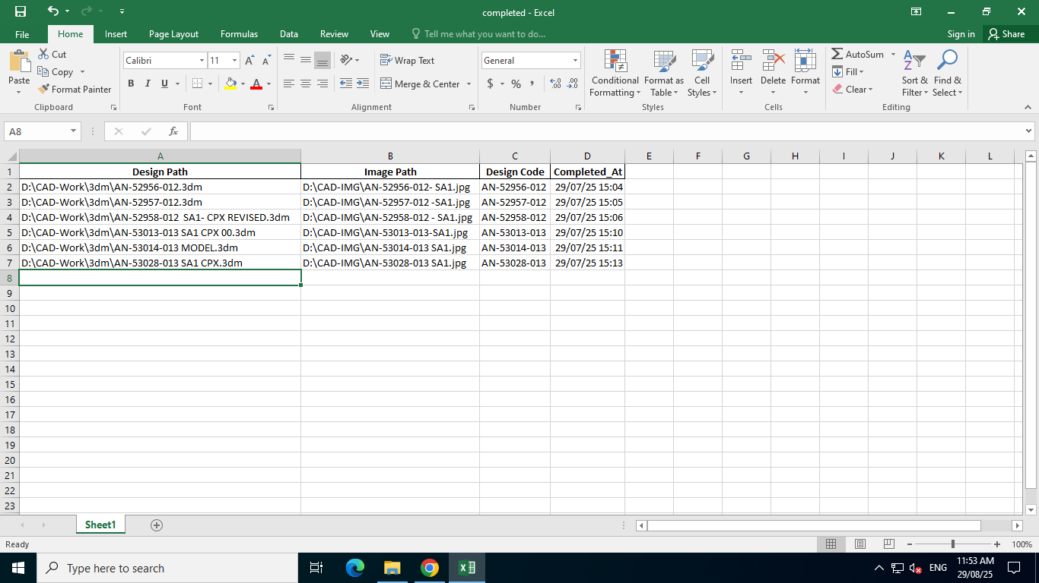
- Skip.xlsx
